Company Profile

WETEX is a leading buying house/agent office located in Dhaka, Bangladesh and we aim to be the preferred supplier in Bangladesh for all of our clients globally. Our website includes product research and development, sourcing, merchandising and quality assurance. Our business policy is to provide the best Quality, Sincerity, Honesty and we offer and ensure the best possible pricing to our all clients.

### WHAT WE DO

Our products are all kinds of Knit, Woven & Sweater such as: T-shirt, Polo shirt, Sweatshirt, Pants, Shirts, Jackets, Skirts, Blouses, Shorts, Undergarments, Socks, Towel, Jute & Home-textile Accessories etc. with various designs and types for men, ladies & kids.

### OUR VISION

Our Vision is to produce exceptional quality Knit, Woven and Sweater Garments for our Customers; our aim is to undertake orders of large capacities with best prices.

OUR PHILOSOPHY

To produce fashionable basic styles in a good quality and with the best value for money prices. We are always welcome new cooperation’s with new customers and mind open to receive new trends and designs.

OUR PROCESS:

Design at our core, care from the start.

* Product research and development,
* Sourcing,
* Merchandising and
* Quality assurance.

OUR TEAMSPRIT



# OUR VALUES

* We take ownership
* We work collaboratively
* We are determined & reliable
* We thrive to exceed
* We aim to continuously improve.

# OUR CAPABILITIES

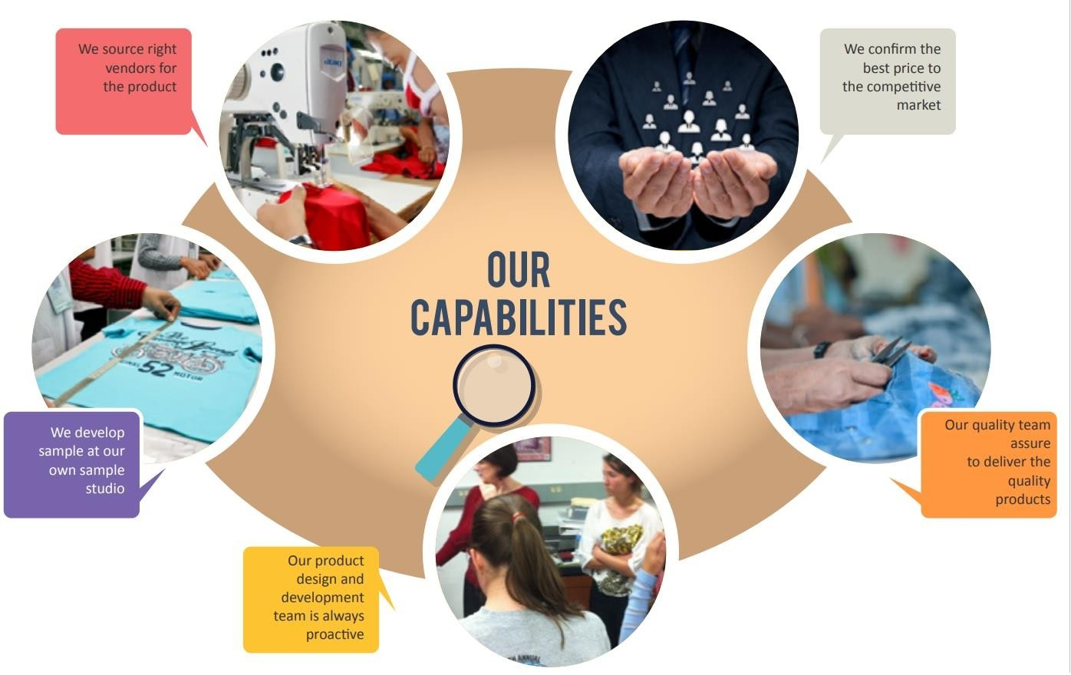

# HOW WE WORK

# 

# OUR OFFER

# 

* We work very low commission and working for good brands.
* We can check and monitor the process the order placement to sampling to shipment.
* We offer competitive prices
* We timely delivery of the product.
* We have sourcing knowledge.

# OUR CULTURE

# Safety, Security, Success

* Working Environment
* Care
* Complimentary Food
* Development
* Atmosphere and
* Education

# OUR CLIENTS

* Moririn, Japan
* Kowa, Japan
* Toms, Japan
* Aparela, UK
* Tamnoon Apparel, Israel
* Just Group, Australia

Costco, U

# OUR PRODUCT:

# From design to finished product.

# Knit

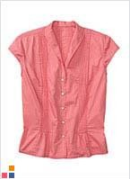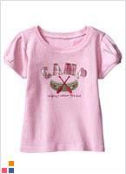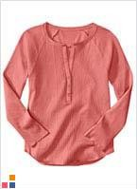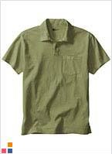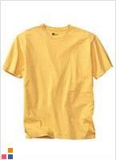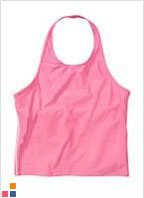

Woven

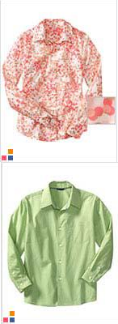

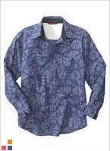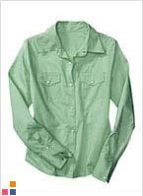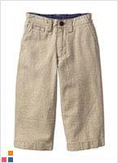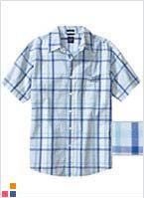

## Sweater

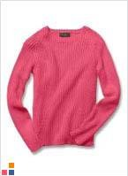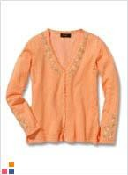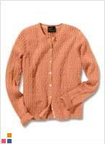

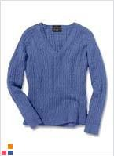

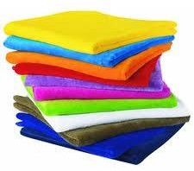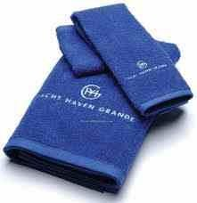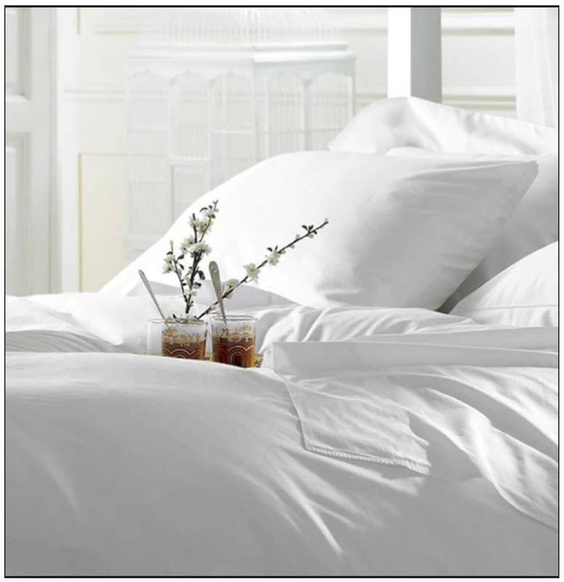HOMETEXTILE

LEATHER

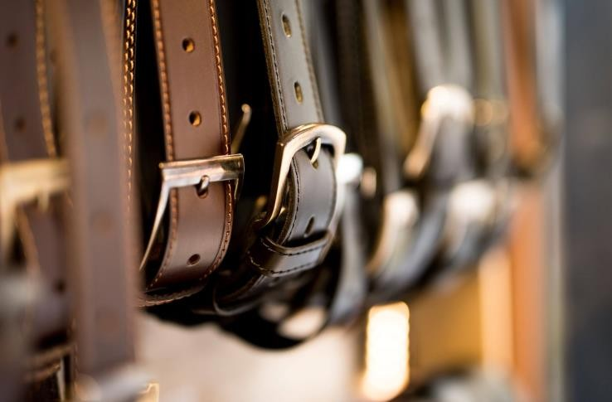

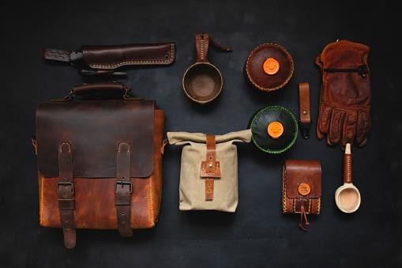 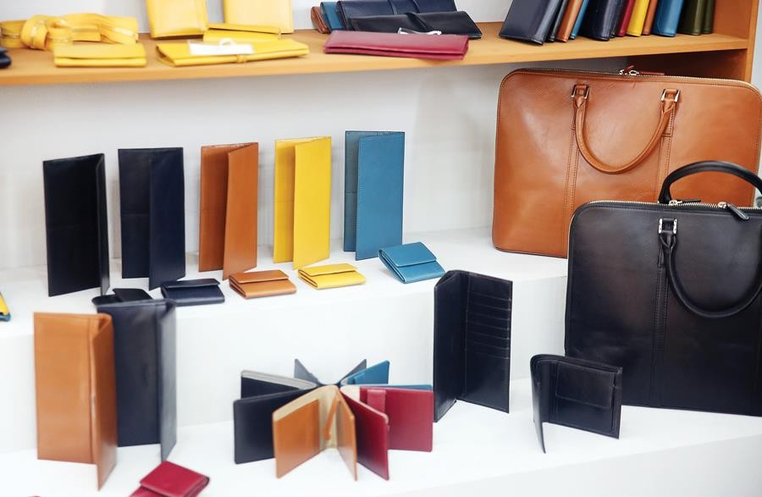

We are always ready to listen to your questions, suggestions and requests-in writing, by e-mail or by telephone.

Dhaka Office

Address: House No 20, Road No 8, Sector 4, Uttara, Dhaka-1230, Bangladesh

Tel: +880 1711374101

E-mail: [babul@wetex.com.bd](mailto:babul@wetex.com.bd);

wetex.dhaka@gmail.com;

[info@wetex.com.bd](mailto:info@wetex.com.bd),

Australia Office:Mr. Montry

France Office: Mr. Corentine

Denmark Office: Mr. Shafi

# Contact Form

# Name:--------------------

# Mail:---------------------

# Message:----------------

# Send